PHASE 1 — CONCEPT & DESIGN

1. Business Concept

Folio — Books & Stationery
Business Type: Mobile Bookstore and Stationery Kiosk
Category: Education — Book / School Supply Store
Folio is a mobile bookstore and stationery kiosk designed to provide books, school supplies, and everyday writing materials in a compact and accessible space. The kiosk combines a small bookstore with a stationery shop, allowing customers to browse and purchase items such as notebooks, pens, pencils, folders, books, and other school or office supplies.
The design focuses on creating a warm, organized, and inviting bookstore atmosphere despite the limited space of a mobile kiosk. Wooden shelves are used to display books and stationery products, while warm lighting gives the interior a comfortable reading and shopping atmosphere.
The kiosk is designed with a dark green, natural wood, and warm cream color scheme. This gives Folio a classic bookstore appearance while keeping the design simple and suitable for a mobile business.

Main Products
The kiosk will display at least the following products:
- 📚 Novels and Fiction Books
- 📖 Non-Fiction Books
- 📕 Classic and Literary Books
- 📗 Educational and Reference Books
- 📘 Self-Help and Personal Development Books
- 📰 Magazines and Reading Materials
- 📔 Journals and Reading Notebooks
- 🔖 Bookmarks
- 📖 Book Covers

2. Store Name

FOLIO
The name Folio is derived from the Latin word folium, meaning “leaf” or “sheet of paper.” It has a strong connection to books, reading, publishing, and stationery.
In the publishing and literary world, a folio refers to a large-format book or a sheet of paper folded to form pages. It can also refer to a specific page or numbered sheet within a book.
The name Folio was chosen for the kiosk because it represents the simple and timeless nature of books and paper products. Its elegant and sophisticated sound also reflects the kiosk’s focus on books, stationery, and other reading and writing essentials.

Books & Stationery
Meaning/Concept:
The name Folio is associated with a sheet or collection of pages and is strongly connected to books, writing, and printed materials. It provides a simple and professional identity for a bookstore and stationery business.

Branding Concept
Primary colors:
- Dark Forest Green
- Natural/Walnut Wood
- Warm Cream
- Black/Dark Gray accents
Logo concept:
An open book icon combined with the word Folio.

3. Concept Sketch

Concept Sketch — Folio Books & Stationery

Figure 1. Initial concept sketch of the Folio mobile bookstore and stationery kiosk.
The concept shows a compact stationary outdoor kiosk with:
- Solid wooden structural framing
- Curved / arched canopy roof
- Large front service opening with wooden counter
- Built-in book display shelves
- Warm interior pendant lighting and LED strip under the canopy
- Side branding panel with the Folio logo
- Lower storage cabinets under the counter
- Clean, permanent outdoor bookstore appearance (no wheels or trailer elements)

4. Reference Images

Reference Image 1 — Stationary Kiosk Structure
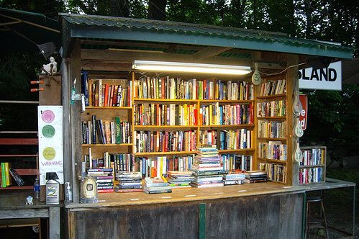

5. Basic Kiosk Dimensions
Blender Unit: Meters (m)

Overall Kiosk Dimensions
- Overall Width: 3.20 m
- Overall Depth: 2.20 m
- Overall Height: 2.60 m
- Body Height (to underside of roof): 2.10 m
- Roof / Canopy Height: 0.50 m
- Service Counter Height: 1.00 m
- Counter Depth: 0.50 m
- Service Opening Width: 2.60 m
- Service Opening Height: 1.30 m
- Side Panel Depth: 2.20 m
Interior Dimensions
- Bookshelf Height: 1.60 m
- Bookshelf Depth: 0.30 m
- Counter Width: 2.60 m
- Lower Storage Height (under counter): 0.70 m
- Main Working / Browsing Space: approximately 1.20 m (front to back behind the counter)

